

Schools must use the funding to make additional and sustainable improvements to the quality of PE and sport they offer. This means that you should use the Primary PE and Sport Premium to:

- develop or add to the PE and sport activities that your school already offers
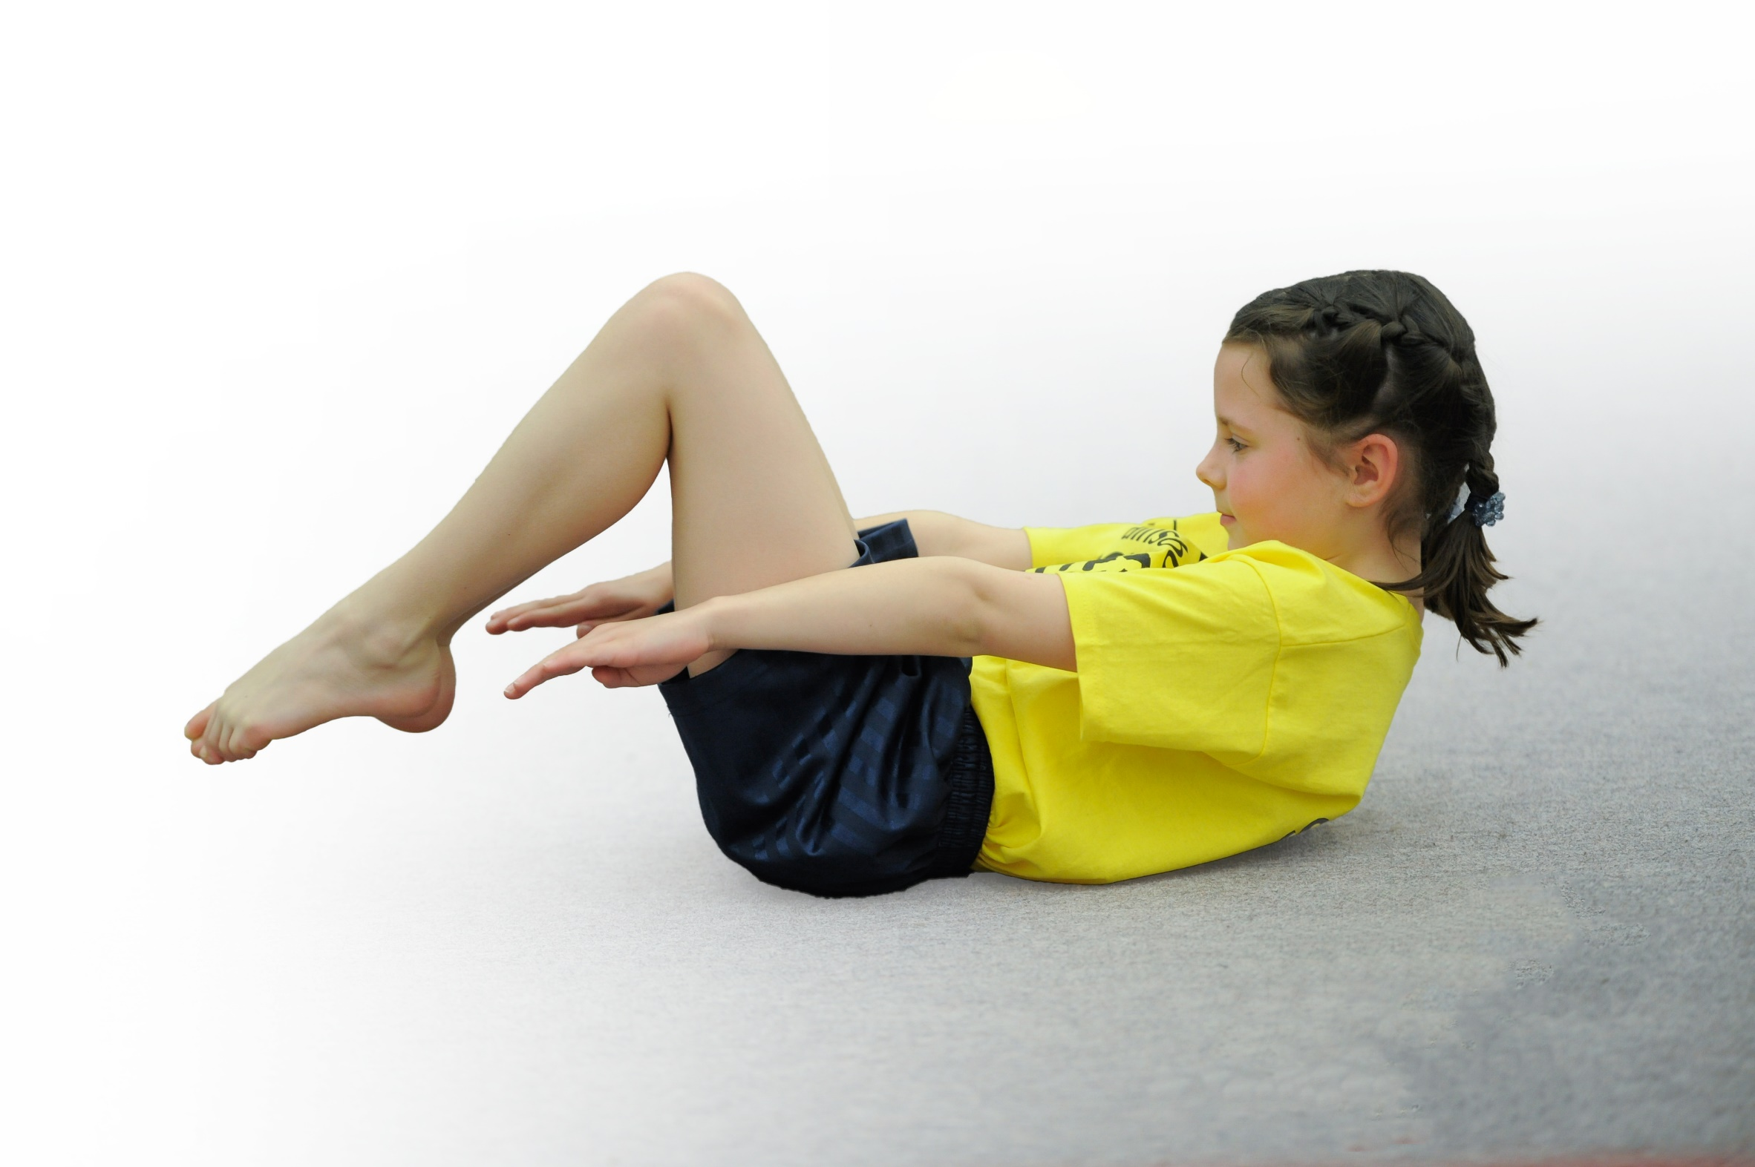
- build capacity and capability within the school to ensure that improvements made now will benefit pupils joining the school in future years

Please visit gov.uk for the revised DfE guidance including the 5 key indicators across which schools should demonstrate an improvement. This document will help you to review your provision and to report your spend. DfE encourages schools to use this template as an effective way of meeting the reporting requirements of the Primary PE and Sport Premium.

We recommend you start by reflecting on the impact of current provision and reviewing the previous spend.
Under the Ofsted Schools Inspection Framework, inspectors will assess how effectively leaders use
the Primary PE and Sport Premium and measure its impact on outcomes for pupils, and how effectively governors hold them to account
for this.

Schools are required to publish details of how they spend this funding as well as on the impact it has on pupils’ PE
and sport participation and attainment.
We recommend regularly updating the table and
publishing it on your website as evidence
of your ongoing review into how you are using the money
to secure maximum, sustainable impact. To see an example of how to complete the table please click HERE.

Support for review and reflection - considering the 5 key indicators from DfE, what development needs are a priority for your setting and your students now and why? Use the space below to reflect on previous spend, identify current need and priorities for the future.

Key achievements to date: | Areas for further improvement and baseline evidence of need:
- All children receive at least 21/2 hours of curriculum P.E. per week.  - All year 4, 5 and 6 children included in at least 1 festival and all year 5 and 6 in at least 2 festivals, including SEND and inactive children.  - Children involved in extra-curricular sport each week.  - Participated in 7 inter-school sports. More than 1 team were entered in 2 sports.  - All children from year 3-6 participated in intra-school sport  - More P.E. space at school available because of changes to parking  - Real P.E. curriculum implemented – nearly all staff trained.  - Resources up-graded  - Small schools sport competitions including sports leader training  - Playtime equipment up-graded  - Success in festivals (won 2 small schools festivals and reached the final group in 2 large school festivals)  - Be the Best programme | - Extra storage for equipment at the Kennet Valley Hall to enable purchase of gym and other indoor equipment  - More links with clubs  - Coaches to come into school to work with children  - Further improvement to space at school (better car-parking, all weather surface, Improved play equipment  - Continued use of Kennet Valley Hall, including for clubs  - Sports leader training for all year 5 and 6 (booked)  - Mile a day  - Sports mark award  - Improve extra-curricular involvement of 14 least active children identified in the Autumn.  - More children involved in extra-curricular sport  - All year 6 children to be sports leaders during the summer term

Meeting national curriculum requirements for swimming and water safety | Please complete all of the below*:
What percentage of your current Year 6 cohort swim competently, confidently and proficiently over a distance of at least 25 metres? | 88.2%
What percentage of your current Year 6 cohort use a range of strokes effectively [for example, front crawl, backstroke and breaststroke]? | 84%
What percentage of your current Year 6 cohort perform safe self-rescue in different water-based situations? | 33.6%
Schools can choose to use the Primary PE and Sport Premium to provide additional provision for swimming but this must be for activity over and above the national curriculum requirements. Have you used it in this way? | Yes/No
*Schools may wish to provide this information in April, just before the publication deadline.

Action Plan and Budget Tracking
Capture your intended annual spend against the 5 key indicators. Clarify the success criteria and evidence of impact that you intend to measure to evaluate for students today and for the future.

Academic Year: 2017/18 | Total fund allocated:  £15,202.00 | Date Updated:  April 2018 – Total spent to date – £12,057.02  79% of total Fund allocated
Key indicator 1: The engagement of all pupils in regular physical activity – Chief Medical Officer guidelines recommend that primary school children undertake at least 30 minutes of physical activity a day in school |  |  |  | Percentage of total allocation:
 |  |  |  | 2%
School focus with clarity on intended impact on pupils: | Actions to achieve: | Funding allocated: | Evidence and impact: | Sustainability and suggested next steps:
- All children take part in afternoon of PE at local village hall.  - More active time for all.  - Improved fitness for less active  - Enjoyment of sport for life.  - Children to go on to secondary education wanting to pursue sports and activities. | Use of the Kennet Valley Hall including for clubs  Additional lesson in school for all children (Real P.E.)  Clubs provided, including sports for the less active in ‘Dragon club’ (accessed by children that may not sign up for sports clubs)  Extra playtime equipment | £217.62 | High Vis jackets bought for walk up to the hall – safeguarding. Also wear them at sports festivals and when completing other cross curricular exercise such as village walks.  All children received a water bottle at the start of the year so that they can access water throughout day and during sports. This also helps us to promote a healthy lifestyle.  21/2 school P.E. per week for all  More activity by a greater proportion of children in playtimes  Children in ‘Dragon club’ active each day  Higher take-up of after-school clubs  Enthusiasm from parents  Success in festivals  Keenness for less active to participate in festivals and intra-school sport | Reward system to ensure children are also being physical at home.  Gain a sports mark at end of 2017/18 academic year, and then another at end of 2018/19 year.
Key indicator 2: The profile of PE and sport being raised across the school as a tool for whole school improvement |  |  |  | Percentage of total allocation:
 |  |  |  | 48%
School focus with clarity on intended impact on pupils: | Actions to achieve: | Funding allocated: | Evidence and impact: | Sustainability and suggested next steps:
- To show that Kennet Valley School can achieve well and achieve sporting success  - Weekly PE at the Kennet Valley hall – whole school PE, including Year 6 children taken turns to lead these sessions.  - School focus with clarity on intended impact on pupils:  All children in year 4- 6 to participate in festivals  Greater success in festivals  Increase fitness and therefore alertness in lessons  Less active participating | Real P.E. scheme, including training for all staff  Involvement in small school sports  Kennet Valley Hall, including after school clubs  Intra-school sports  Festivals  All children to take part in these sessions. Children to design and run these sessions  Improved sports day | £5787.05 =  Sports Staff (Including at festivals) = £3900.80  Hall Hire / Venue  £1886.25 | All year 5/6 participated in at least 2 festivals and all year 4 in at least 1 festival.  Positive feedback from parents  Most staff teaching P.E.  Parents supported children at festivals  Parents attended open Kennet Valley Hall session  11 of 14 identifies as less active participated in extra-curricular activity  Charges for Kennet Valley Hall – all children take part in a weekly whole afternoon. This ensures that the profile of PE and sports has been raised throughout the school.  These sessions have also helped children to achieve more, and be more confident during sports competitions and festivals. | To achieve Sports Mark (either Bronze or Silver)  Sports leader training for all year 5/6  More sports aimed at less active e.g. yoga  Sport linked to class lesson – extra curricular

Key indicator 3: Increased confidence, knowledge and skills of all staff in teaching PE and sport |  |  |  | Percentage of total allocation:
 |  |  |  | 27%
School focus with clarity on intended  impact on pupils: | Actions to achieve: | Funding  allocated: | Evidence and impact: | Sustainability and suggested  next steps:
- All children to have a longer PE session each week, where they take part in a wider range of activities  - Increased knowledge of sports coaching, including swimming teaching  - Extra P.E. sessions  - Increased staff confidence and skills | All staff trained on REAL PE  REAL PE used in PE lessons throughout the week and at the KVH  Members of staff to work with swimming teacher at the pool to learn new strategies.  Kennet Valley Hall - whole school, including staff involved and dressed correctly. Confident to support less confident. | 3212.05 Total =  REAL PE £2195.00  PE Coaches = £1017.05 | 9 members of staff attended the REAL PE training at school.  This programme was used throughout the week to teach sports skills which could be used in other PE lessons and in sports competitions and festivals.  Improvement to provision of sports and PE across the school.  Extra fitness | Real PE to continue and to be sued more on a WED at the KVH
Key indicator 4: Broader experience of a range of sports and activities offered to all pupils |  |  |  | Percentage of total allocation:
 |  |  |  | 17%
School focus with clarity on intended  impact on pupils: | Actions to achieve: | Funding  allocated: | Evidence and impact: | Sustainability and suggested  next steps:
- Increase range of activities offered in our curriculum to get more pupils involved in PE and sports.  - To widen the range of pupils who take part in the clubs that we offer, and for staff to gain more experience at offering new clubs.  - To track and recognise that all children should participate in sports, including after school sports clubs.  - Additional involvement in festivals  More active children  Health  Fitness  Enthusiasm | Additional involvement in festivals  More active children  Health  Fitness  Enthusiasm | £2014.05 =  REAL PE Equipment = £203.30  Clubs coaching = £952.00  Sports hall and venue hire =  £858.75 | Real PE equipment sets bought to ensure that staff are able to teach this strategy well.  Coaching for clubs (lunchtime and after school) – staff learnt greater skills for a range of sports.  Kennet Valley Hall hired to ensure that all children have opportunities to access a wide range of sports throughout the term. Build on team games and individual skills.  Extra participation  More enthusiasm from less active  All year 4-6 in festivals including SEND and less active  Parents supporting festivals  Children wanting to join more clubs outside school | Add more extra-curricular sports to appeal to a wider range of tastes
Key indicator 5: Increased participation in competitive sport |  |  |  | Percentage of total allocation:
 |  |  |  | 7%
School focus with clarity on intended  impact on pupils: | Actions to achieve: | Funding  allocated: | Evidence and impact: | Sustainability and suggested  next steps:
Children to understand that competition is for all and to want to do it.  Sport for life for all | Festivals, including small school festivals so more accessible  Intra-school competition  All children to participate  Increased range of sports to appeal to all children. | £826.25 =  Equipment for competitions / festivals = £94.36  Hall hire / Venue =  £97.50  Festival costs = £634.39 | Extra equipment bought to use at, and in preparation for, inter-school competitions – including rugby belts and team bands.  Hall hire for sports days and other intra-school competitions  Festival costs for joining local cluster sports competitions.  More enthusiasm from less active  All year 4-6 in festivals including SEND and less active  Parents supporting festivals  Children wanting to join more clubs outside school | Enter all festivals again and increase range to appeal to more e.g. gym, swimming, football

